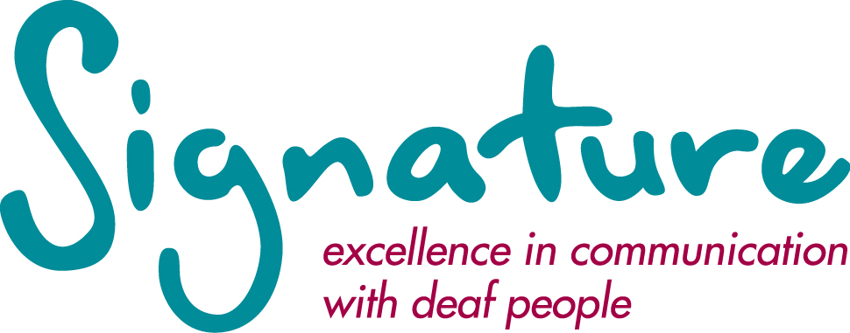

TRUSTEE OF SIGNATURE

The position represents an opportunity to join the Board of an important and vibrant organisation that promotes excellence in communication with deaf people.

Role Description

General Responsibilities

- To promote the vision and objectives of Signature.
- With fellow trustees, to ensure that Signature applies its resources exclusively in pursuance of its objects.
- To attend the Board meetings in support of the activities of Signature.
- To join a relevant sub-committee of the Board and attend meetings, contributing in areas of your own expertise and experience.
- To contribute actively to the Board of Trustees - in giving firm strategic direction to the organisation, setting overall policy, defining goals and setting targets and evaluating performance against agreed targets.
- To ensure the solvency of Signature and that there is probity and propriety in the application of the resources of the charity and that the charity’s funds are properly invested.
- To develop an effective working relationship with the Executive as required.
- To maintain an overview and be assured that plans and budgets agreed by the Board are monitored, delivered and evaluated by the Executive team.
- Trustees will be expected to work with Signature at functions, meetings or other events and to lobby and act as spokesperson as necessary.
- To promote and enhance the reputation and values of Signature.

Skills and Experience

For the education role, the Trustee should be experienced at a strategic level within a learning and qualifications environment. The Trustee would also serve on the Qualifications Standards Committee.

In addition, the Trustee should be able to:
- contribute to the Board following Nolan’s seven principles of public life: selflessness, integrity, objectivity, accountability, openness, honesty and leadership.
- have an understanding of or the willingness to develop an awareness of issues around communicating with deaf, deafened and hearing people.

Signature’s head office is in Durham, though proximity to the office is not a requirement.

